

**Department of Computer Science & Engineering (CSE)**

**Project Report**

***Employee Data Management System***

Submitted to: Rafeeq sir

Submitted by: Anshika

Roll No.: 2010991483

Group: G-11

Batch: 2020

Submission Date: 19th October, 2022

**Abstract**

The project report has been prepared based on the requirements and instructions given by the sir. The real-life scenario can be a little different that depends upon the different circumstances. The project has come into existence to manage the employee data in a company. This project has been named as “*Employee Data Management System*”.

#### **Problem Statement:**

#### Develop a website that will help employee to enter their data in their company’s official website. Employees can also upload images in that. The data can easily be accessed, read, and the entry can be updated or deleted if needed. There will be ‘Login and Registration Authentication’ also.

#### **Problem Solution:**

#### The solution for the above problems can be the:

#### “CRUD (Create, Read, Update, and Delete)” Operations, for accessing the data and images and various operations to be performed on that data.

#### Local storage to provide the authentication.

#### 

#### **Functional Description:**

#### Sign In & Sign Up is offered. Firstly, user has to register himself only then they can access the site.

#### They can enter their details, and can read, update or delete it anytime.

#### **Aim of the Project:**

#### The ultimate aim of the project is to apply the ‘CRUD’ (Create, Read, Update and Delete) operations on the data entered by the employees. The other objective of the project is to set the ‘Login and Registration Authentication’, and to apply CRUD operations on images.

#### **Key Features and Scope of the Project:**

#### A detailed interface.

#### Users can easily access it and use it.

#### Completely responsive as reactjs has been used.

#### Style formatting.

#### Amazing UI/UX.

#### Full effort has been given to this project, so that it can be taken into account. However, the report isn’t full proof. There is always room for improvement in this project.

**Contents**

1. Introduction 1
2. Home Page 2
3. Sign In Page 3
4. Sign Up Page 4
5. Employees Page (CRUD Operations) 5
6. Contact Page 6
7. About Page 6
8. Navbar7

**Introduction**

The project contains a Home Page, a Nav Bar, an About Section, a Login Page, a Sign-Up Page, a Contact Section. ‘Reactjs’ has been used in this project, and is completely responsive website. ‘Bootstrap’ is used for the designing. To access the website, firstly user has to register himself/ herself only then they can use the functionalities. Anyone can easily access this website as a very user-friendly interface has been developed for the users. There is a page where employees can enter their data and also upload the images.

**Navbar**



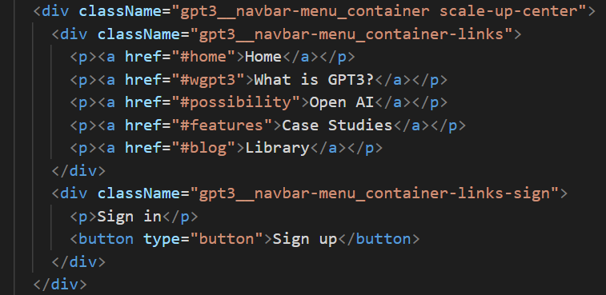

**Home Page**



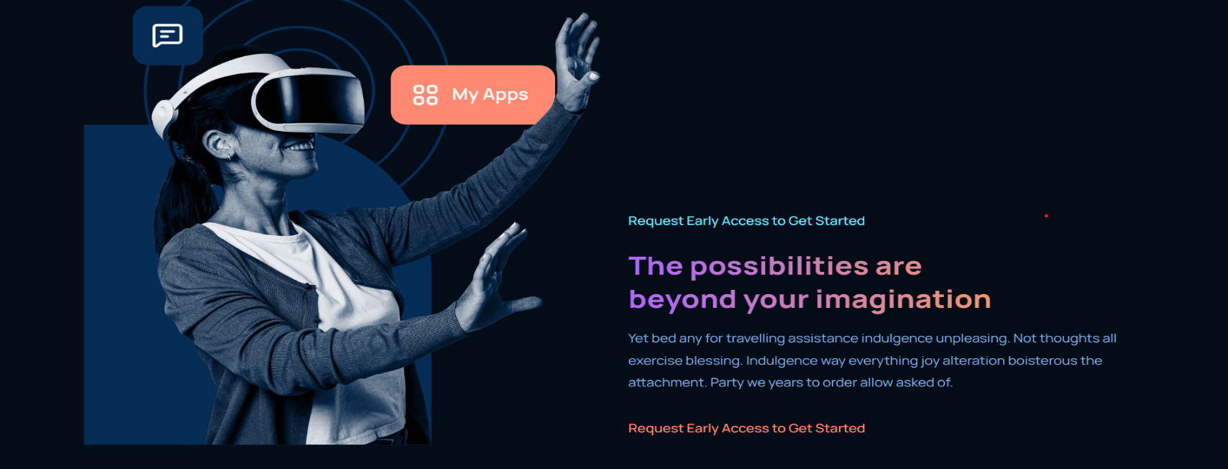

**Sign In Page**



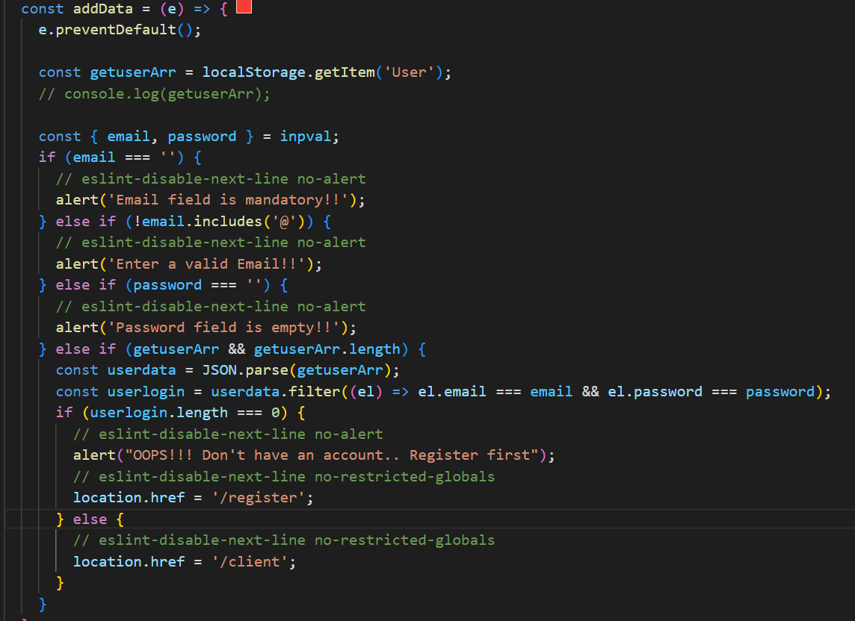

**Sign Up Page**

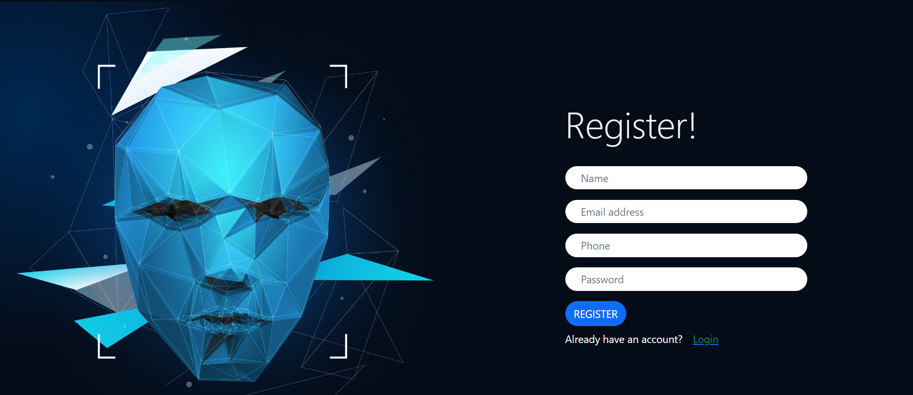

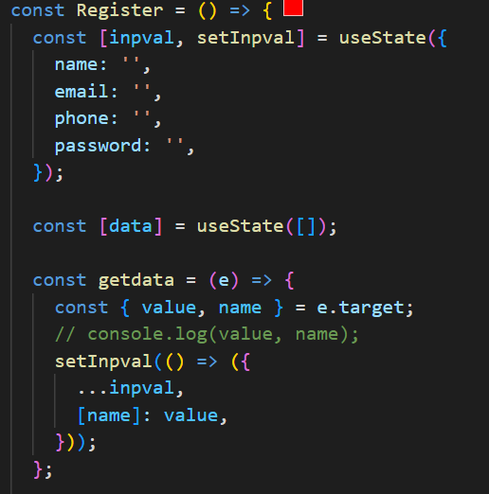

**Employees Page (CRUD Operations)**

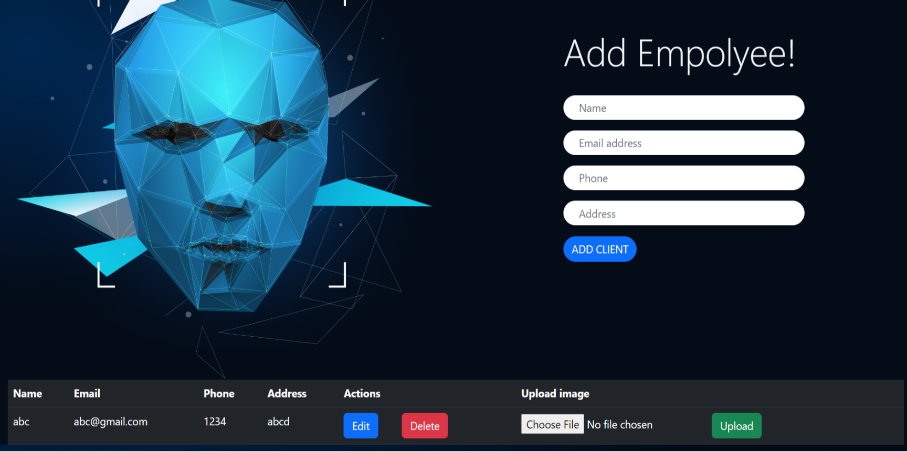

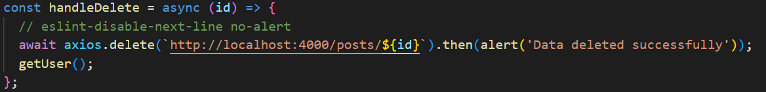

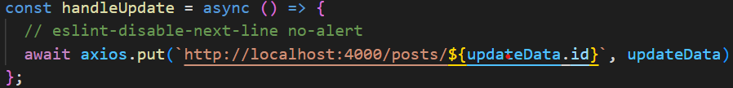



**Contact Page**



**About Page**

